3 | from | to | designation |  | surface | Min width | wheelchair?
3 | Hulham Rd | Marley Rd | E Devon Way |  | rough | 1.5m | No – see note
3 | Comments – the path is steep at the Hulham Rd end but motorised wheelchairs might manage
photo | 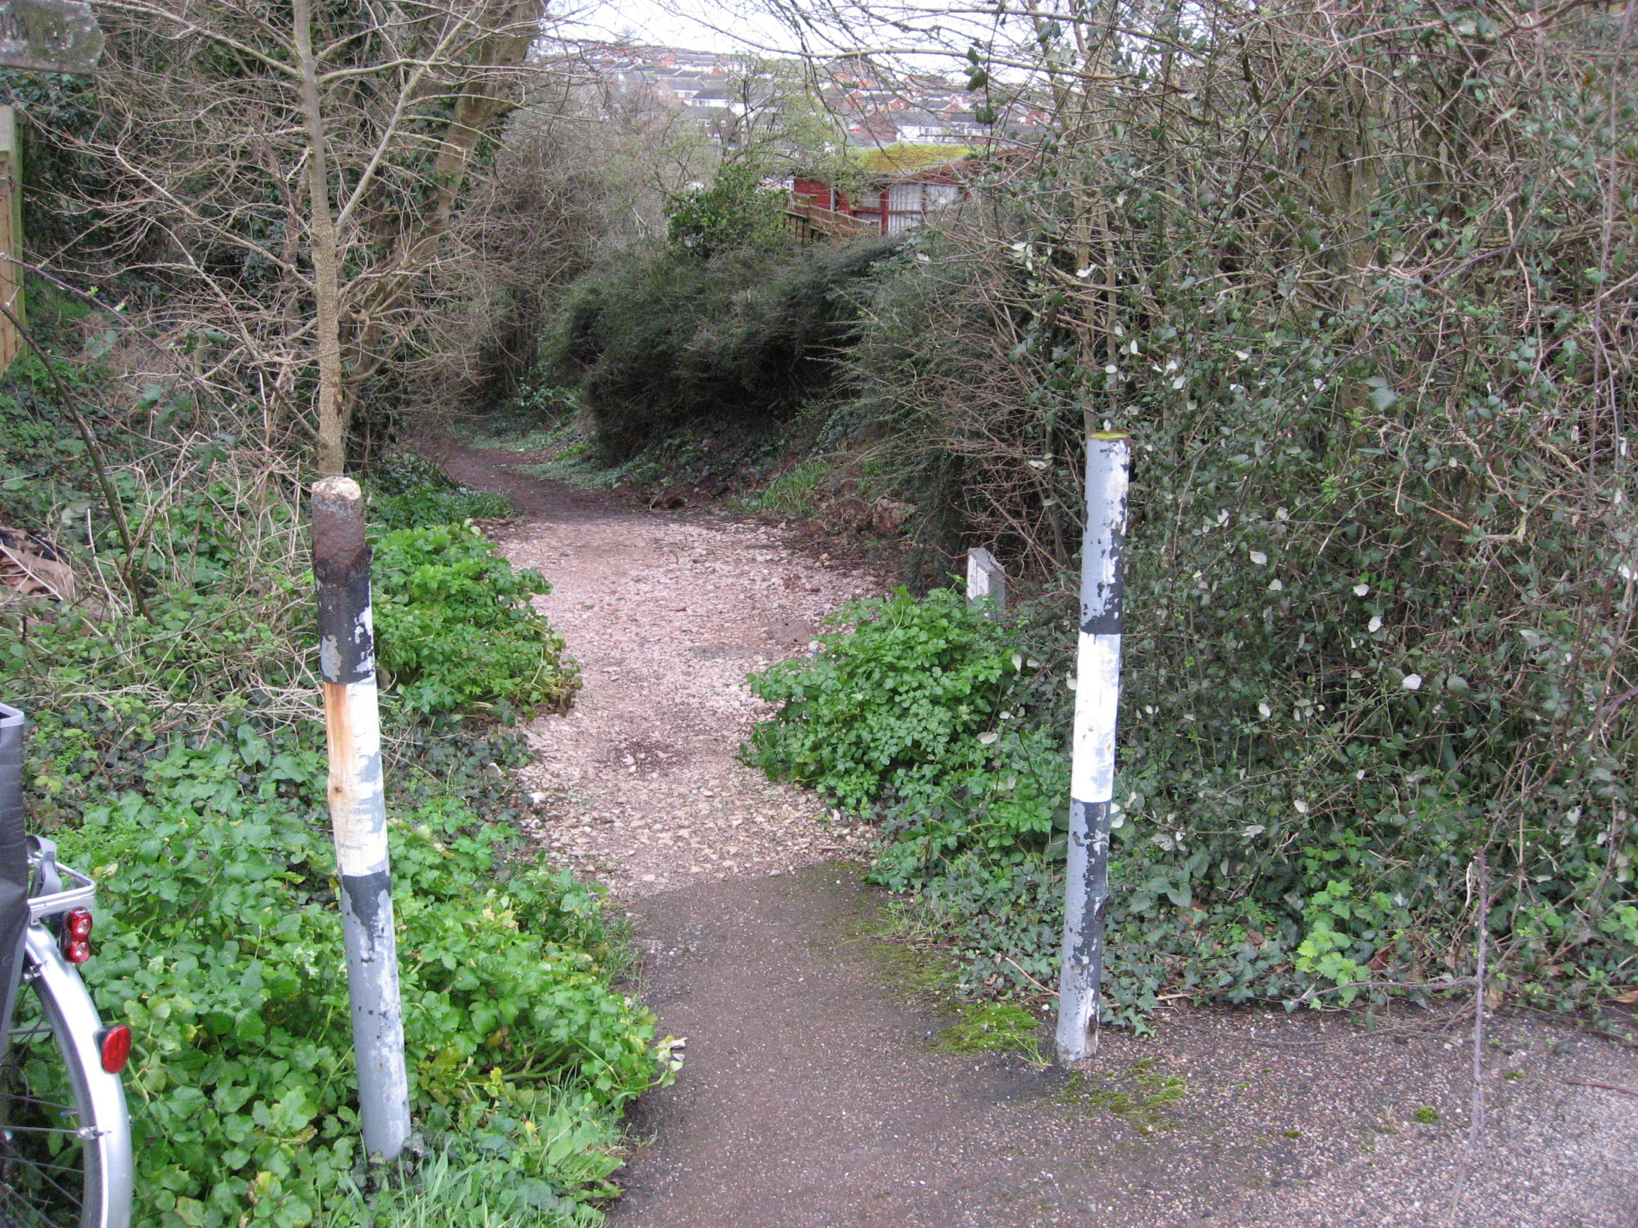  Entrance to path from Hulham Road |  |  | 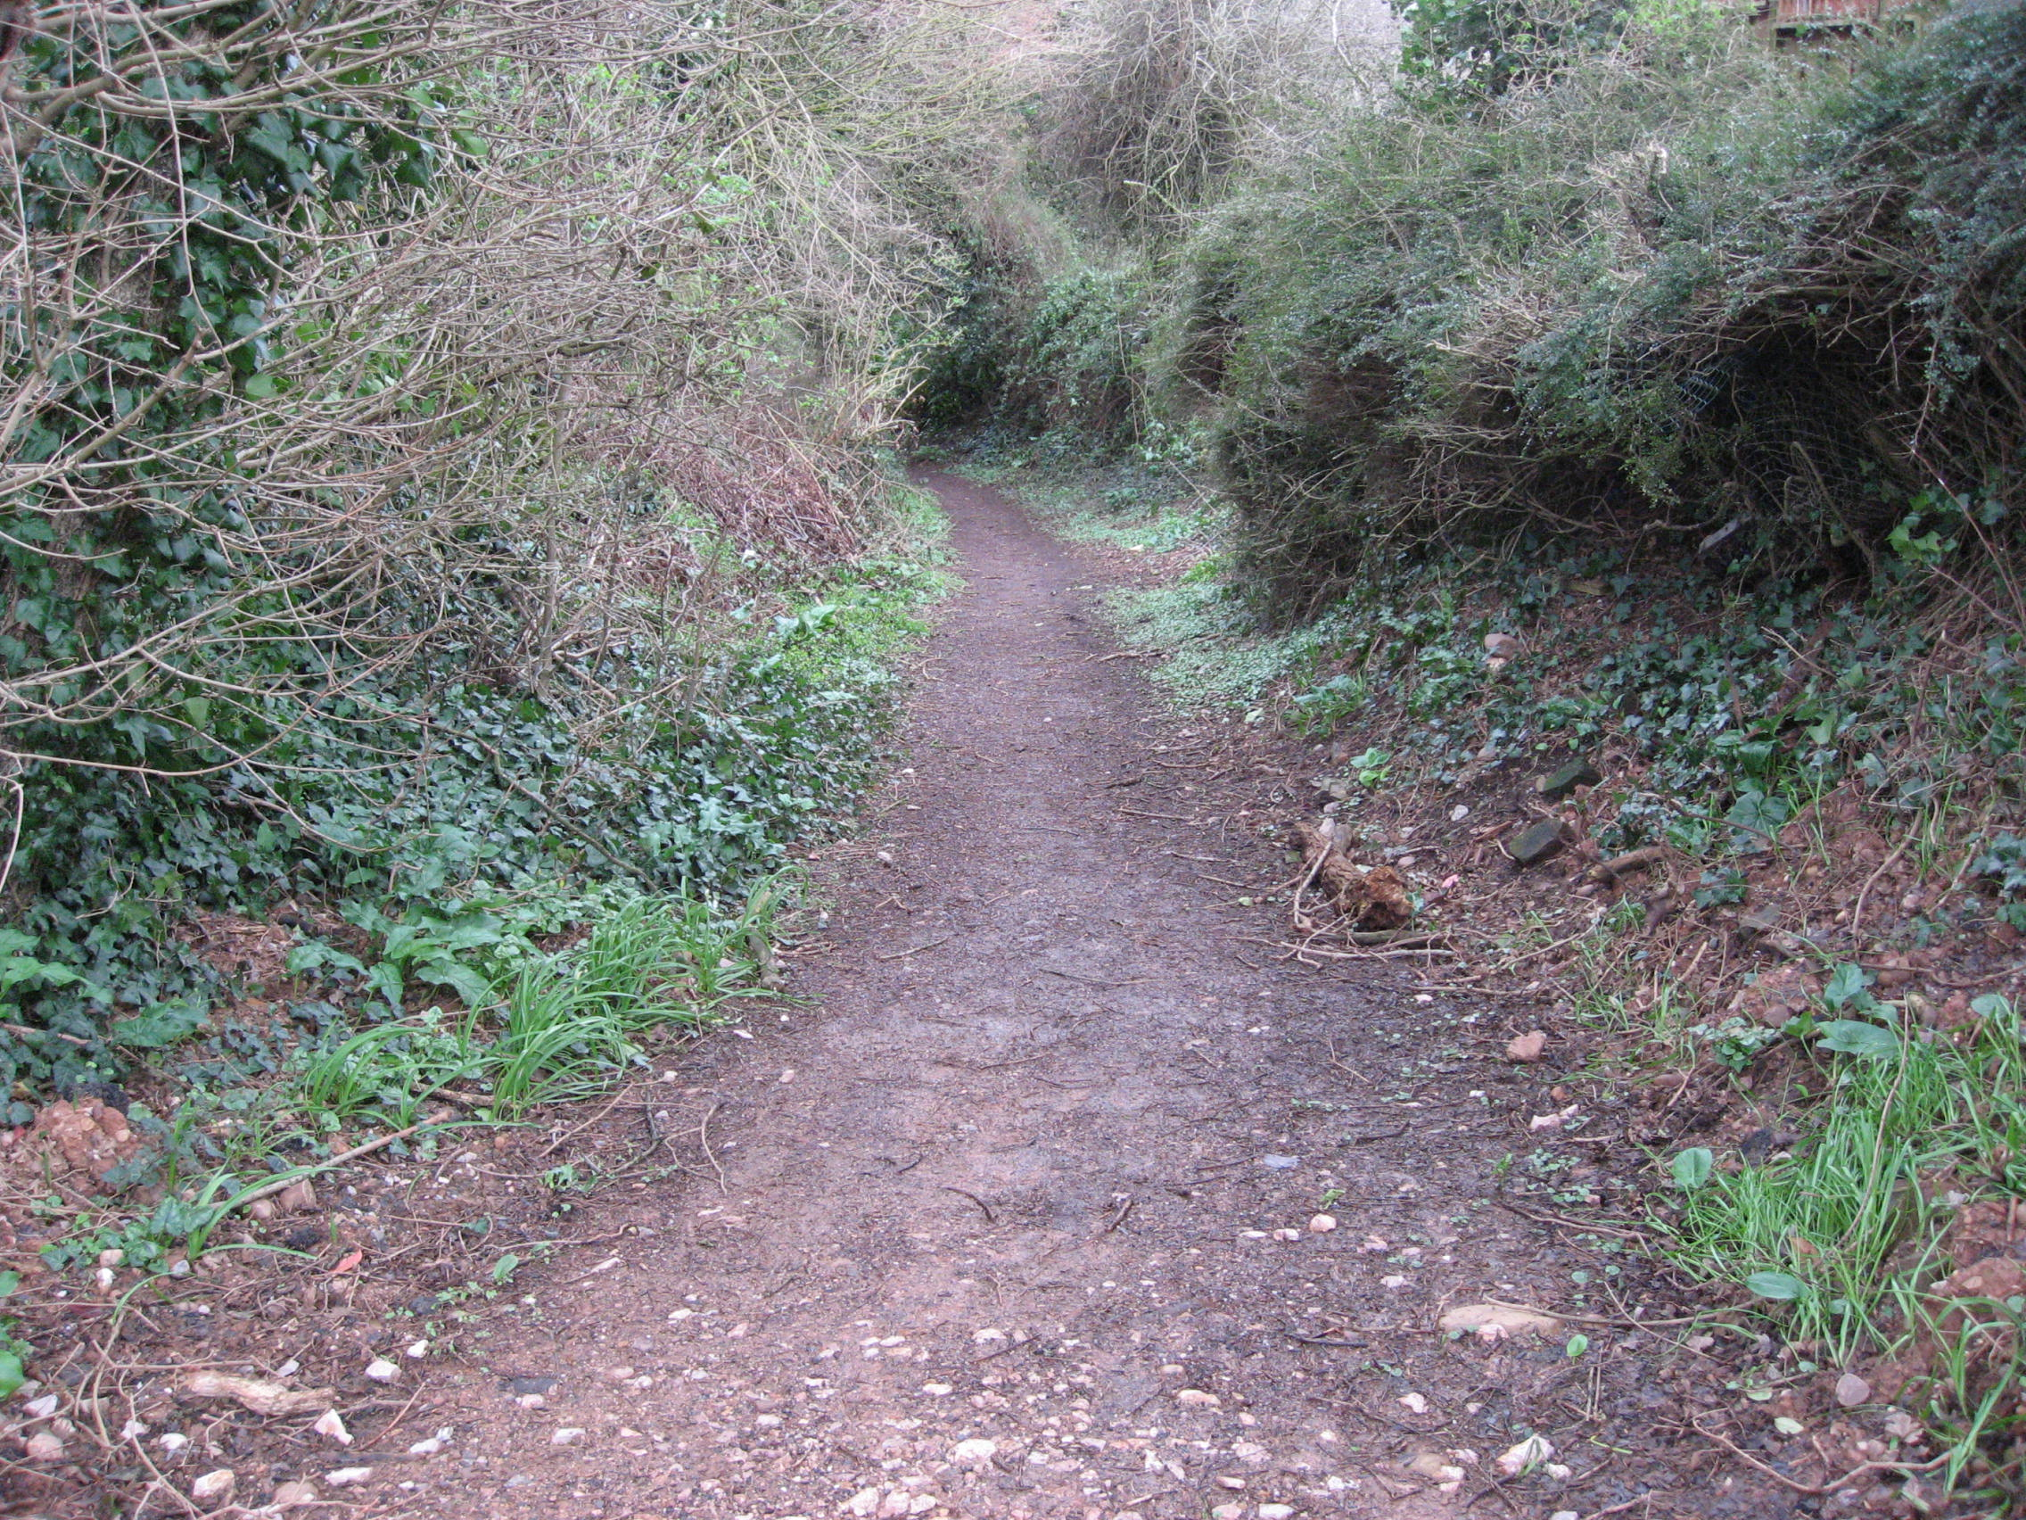
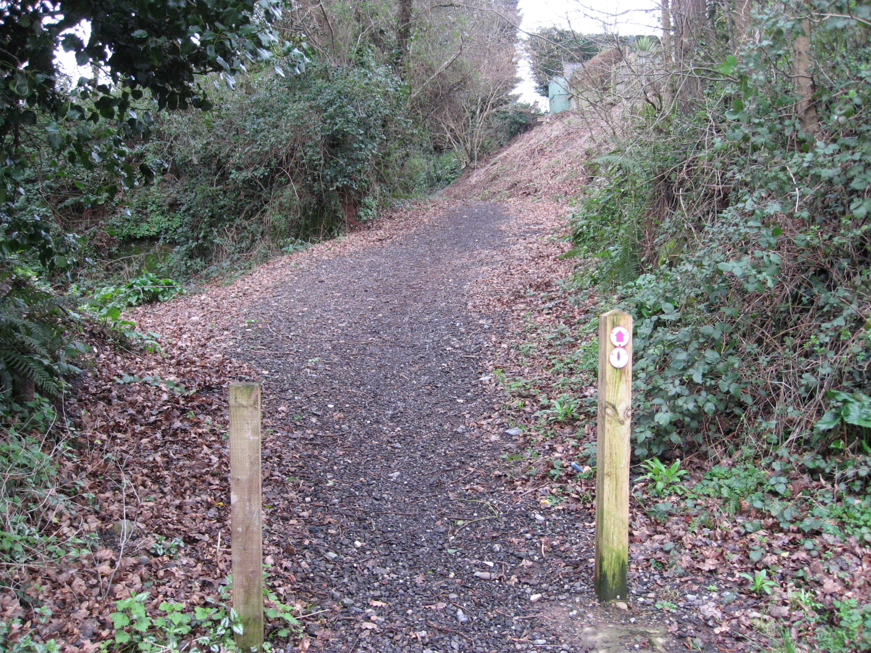
Entrance to path from Marley Road

